SIGNAL GENERATOR USING DIRECT DIGITAL SYNTHESIS

Submitted by: KARTHIKEYAN N [CB107EC038]
PRABHAKARAN K [CB107EC042]
GOWTHAM SHITHARTH B [CB107EC031]
KARTHIK B [CB107EC036]

Submitted to: Mr. MOHAN KUMAR,
AMRITA VISHWA VIDYAPEETHAM



AMRITA SCHOOL OF ENGINEERING
ETTIMADAI, COIMBATORE-641105
Signal Generator using Direct Digital Synthesis
ABSTRACT:
Signal generators are generally large in size due to its bulky hardware and it is not portable also. Also it can only generate particular set of waveforms. We cannot create any arbitrary waveform. Nowadays digital signal generators are available but still it is not reconfigurable and it cannot create any type of waveform we want.
In our project we use FPGA to realize all the hardware parts of signal generator in a better way and we use a method called Direct Digital Synthesis to realize any type of waveform we want. We use a single chip to realize signal generator. Direct Digital Synthesis (DDS) is a method for digitally creating arbitrary waveforms from a single, fixed-frequency reference clock. DDS has many advantages over its analog counterpart and improved phase noise. It has precise control of the output phase across frequency switching transitions.
The output of FPGA will be digital and this digital data is given to Digital-to-Analog Convertor (DAC). DAC converts the digitally created signal to analog form thus creating a versatile, flexible signal generator. The DAC and FPGA share a single clock source. Since we are using FPGA as a hardware part, in future easily upgrade the signal generator by altering the FPGA design. There is no need of extra cost to buy new signal generator unlike analog signal generator.
Three main units of this project are
- Clock Source
- FPGA
- DAC
FPGA

DAC
DDS
Digital data
Clock Source

Introduction:
Our project deals with the implementation of Direct Digital Synthesis using VHDL code in FPGA. DDS is a technique to generate the digital values of any waveform using digital components. Hence this can be easily implemented in FPGA using VHDL or Verilog HDL.
FPGA IMPLEMENTATION OF DIRECT DIGITAL SYSNTHESIS
In our project, we created synthesizable vhdl code for generating various waveforms such as square wave, triangle wave, saw tooth wave, sine wave. The most critical part is the generation of sine wave.
Here we used separate blocks for generation of each wave and a signal selector (similar to multiplexer) is used to select the required output waveform using select lines.
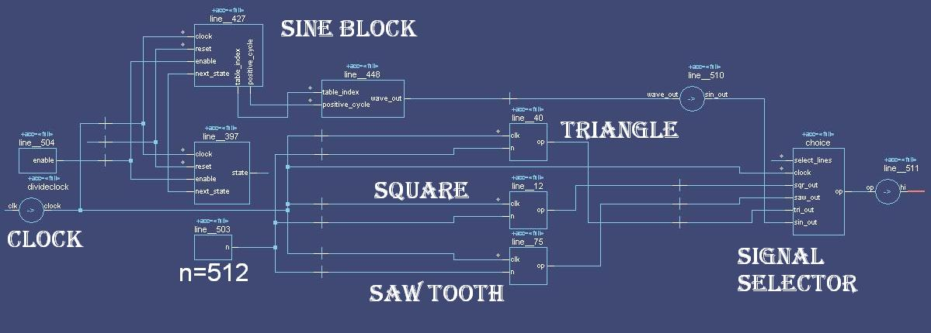
The implementation of DDS is divided into two distinct parts a discrete time phase generator (the accumulator) outputting a phase value ACC, and a phase to waveform converter outputting the desired DDS signal.
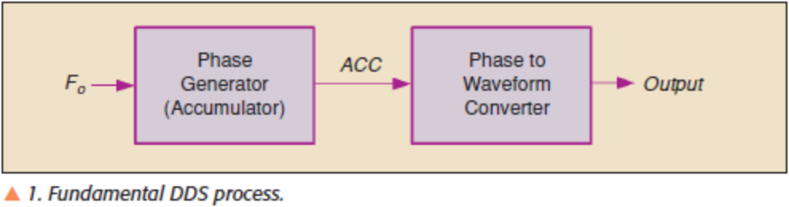
Phase Accumulator:
Phase accumulator is nothing but a counter which resets periodically after n clock pulses. In our accumulator we used n = 512. Hence the period of each waveform will be equal to n clock pulses.
The input to the phase accumulator is clock pulse (1 bit) and ‘n’ value (8 bit).Output from the phase accumulator is an integer – count (16 bit). If we increase this ‘n’ value, the frequency of the generated wave can be decreased. This phase accumulator is common to all the blocks.
Phase to waveform converter:
Phase to waveform converter converts the phase value (count) into the wave form amplitude. This is also called phase to amplitude converter. This block will vary for each wave.
Input to phase to waveform converter is phase ‘count’ (16 bit) and ‘n’ value. And the output is amplitude value ‘wave_out’ (8 bit).
Square wave:
The amplitude of the wave will be high for n/2 samples. Here we took high value as ‘127’ corresponding to all ones. After n/2 cycles, the amplitude will be made low(‘0’).
Saw tooth wave:
The amplitude should be increased to maximum for n samples and then reset to low. Maximum value is ‘127’ and the low value is ‘0’. The rate of increase is inversely proportional to n value.
Triangular wave:
The amplitude has to incremented to maximum till n/2 cycles (from all zeros to all ones). After n/2 cycles, the value has to be gradually decremented to all zeros again.
Sine wave:
The generation of sine wave is the most critical part in creating a DDS signal generator. There are many methods available to generate sine wave. They are
- Taylor series Approximation
- Table lookup.
There are other methods available which are too complicated to implement in FPGA.
- Taylor series Approximation
The Taylor series of the sine function is: sin(x) = x - (x^3)/3! + (x^5)/5! - (x^7)/7! + ...
x is in radians. Since x value is in radians, x should be a floating value. Since we approximate the value, if we take more terms of this series, we get less error. For low values of x, we need only few terms. For higher values of x we need more terms. This kind of approach can be realized by hardware or FPGA. A serious disadvantage of this method is that it requires large no of multiplications to be done. So the hardware implementation is very large. So the cost of implementation is also high.
- Look up table method.
In this method, we first generate the all the sine values for n samples and store it in a memory. In this method, we use the symmetric properties of sine wave. So we need to save only the values of sine wave from 0 to pi/2. This method yields very less error compared to other methods and the hardware realization is also simple.
Memory requirement:
So we chose this method to implement in the hardware. We chose n=512. Therefore we need to store 512/4= 128 sample sine wave values. Because 2*pi/4= pi/2. So we need to store values from 0 to pi/2 only. Other values are generated by symmetric properties of sine wave. For intermediate values we can interpolate between two samples. The no of bits used to store the sample values are 8 bits. So memory needed 8x128 bits= 1024 bits = 128 bytes.
VHDL CODE:
---------------------------------------------------
-- square wave-------------------------------------
library ieee;
use ieee.std_logic_1164.all;

entity sqwav is
port(clk:in std_logic; n :in integer; op:out integer);
end sqwav;

architecture sqwav_arch of sqwav is
begin
process(clk)
variable count:integer:=0;
variable s:integer:=127;
begin
if (clk = '1' and clk'EVENT) then
count := count + 1;
end if;
if(count>=n/2 and count<n) then
s:= 0;
elsif (count>=n) then count:=0;
s:=127;
end if;
op<=s;
end process;

end sqwav_arch;
-------------------------------------------------------------
---- Triangular wave-----------------------------------------
library ieee;
use ieee.std_logic_1164.all;

entity triwav is
port(clk:in std_logic; n :in integer; op:out integer);
end triwav;

architecture triwav_arch of triwav is
begin
process(clk)
variable count:integer:=0;
variable s:std_logic:='0';
begin
if (clk = '1' and clk'EVENT) then
count := count + 1;
end if;
if(count>=n/2) then count:=0;
s := NOT s;
end if;
if(s='0') then
op <= count*255/n;
else
op <= 127-count*255/n;
end if;
end process;
end triwav_arch;

--------------------------------------------------
-- sawtooth wave
library ieee;
use ieee.std_logic_1164.all;

entity sawtoothwav is
port(clk:in std_logic; n :in integer; op:out integer);
end sawtoothwav;

architecture sawtoothwav_arch of sawtoothwav is
begin
process(clk)
variable count:integer:=0;
variable s:integer:=10;
begin
if (clk = '1' and clk'EVENT) then
count := count + 1;
end if;
if(count>=n) then count:=0;
end if;
op<= count*127/n;
end process;

end sawtoothwav_arch;
---------------------------------------------------------
-- sine wave
library ieee;
use ieee.std_logic_1164.all;
use ieee.numeric_std.all;
use work.sine_package.all;

entity sine_wave is
port( clock, reset, enable: in std_logic;
wave_out: out sine_vector_type);
end;

architecture arch1 of sine_wave is
type state_type is ( counting_up, change_down, counting_down, change_up );
signal state, next_state: state_type;
signal table_index: table_index_type;
signal positive_cycle: boolean;
begin

process( clock, reset )
begin
if reset = '1' then
state <= counting_up;
elsif rising_edge( clock ) then
if enable = '1' then
state <= next_state;
end if;
end if;
end process;

process( state, table_index )
begin
next_state <= state;
case state is
when counting_up =>
if table_index = max_table_index then
next_state <= change_down;
end if;
when change_down =>
next_state <= counting_down;
when counting_down =>
if table_index = 0 then
next_state <= change_up;
end if;
when others => -- change_up
next_state <= counting_up;
end case;
end process;

process( clock, reset )
begin
if reset = '1' then
table_index <= 0;
positive_cycle <= true;
elsif rising_edge( clock ) then
if enable = '1' then
case next_state is
when counting_up =>
table_index <= table_index + 1;
when counting_down =>
table_index <= table_index - 1;
when change_up =>
positive_cycle <= not positive_cycle;
when others =>
-- nothing to do
end case;
end if;
end if;
end process;

process( table_index, positive_cycle )
variable table_value: table_value_type;
begin
table_value := get_table_value( table_index );
if positive_cycle then
wave_out <= std_logic_vector(to_signed(table_value,sine_vector_type'length));
else
wave_out <= std_logic_vector(to_signed(-table_value,sine_vector_type'length));
end if;
end process;
end;
--------------------------------------------------------
-- total project entity

library IEEE;
use IEEE.Std_logic_1164.all;
use IEEE.Std_logic_unsigned.all;
use IEEE.Std_logic_arith.all;
use IEEE.Numeric_Std.all;
use IEEE.Std_logic_unsigned.all;
use work.sine_package.all;

entity final_tb is
port( clk:in std_logic; select_lines: in std_logic_vector(2 downto 0); hi: out sine_vector_type);
end;

architecture bench of final_tb is
component sine_wave
port( clock, reset, enable: in std_logic;
wave_out: out sine_vector_type);
end component;
component sqwav is
port(clk:in std_logic; n :in integer; op:out integer);
end component;
component triwav is
port(clk:in std_logic; n :in integer; op:out integer);
end component;
component sawtoothwav is
port(clk:in std_logic; n :in integer; op:out integer);
end component;

signal clock, reset, enable: std_logic:='0';
signal wave_out: sine_vector_type;
signal op,sqr_out,tri_out,saw_out,sin_out: integer;
constant clock_period: time := 37 ns;
signal stop_the_clock: boolean;
signal n: integer:=1;

begin
n<=512;
enable <= '1';
sin_block: sine_wave port map ( clock, reset, enable, wave_out );
sqr_block: sqwav port map ( clock, n, sqr_out );
tri_block: triwav port map (clock, n, tri_out );
saw_block: sawtoothwav port map(clock, n, saw_out);

sin_out<=conv_integer((wave_out));
hi <= conv_std_logic_vector(op,8);

choice: process(select_lines,clock)
begin
if(select_lines="000") then
op <= sqr_out;
elsif select_lines="001" then
op <= saw_out;
elsif select_lines="010" then
op <= tri_out;
elsif select_lines="011" then
op <= sin_out;
elsif select_lines="100" then
op <= sqr_out + saw_out;
elsif select_lines="101" then
op <= sqr_out + sin_out;
elsif select_lines="110" then
op <= sqr_out + tri_out;
else op <= 0;
end if;
end process;
divideclock: process(clk)
variable divider:std_logic_vector(15 downto 0):="0000000000000000";
begin
if( clk='1' and clk'EVENT) then
divider := divider + '1';
end if;
clock <= divider(14);
end process;
end;

Results:
Square wave:
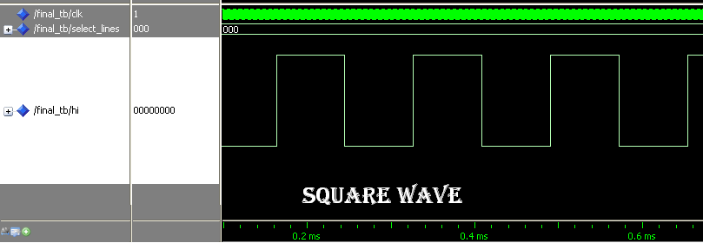
Saw tooth wave:
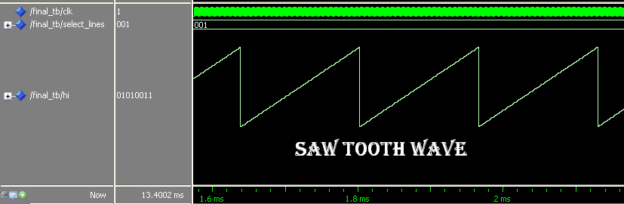
Triangular wave:
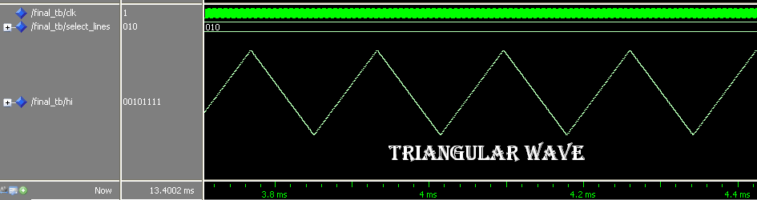

Sine wave:
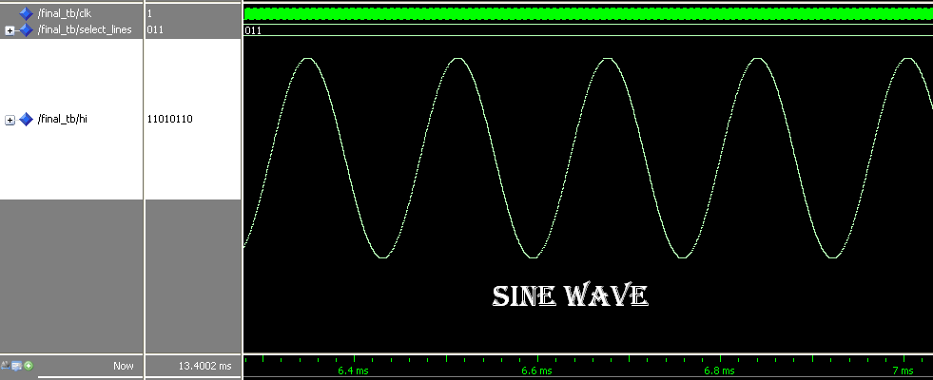
Mixing of two signals:
Square wave + Saw tooth wave
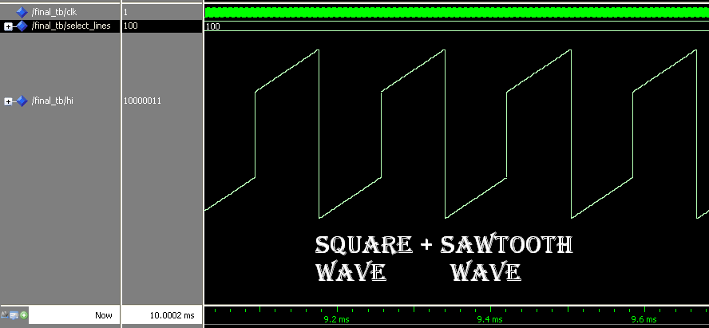

Square wave + sine wave:
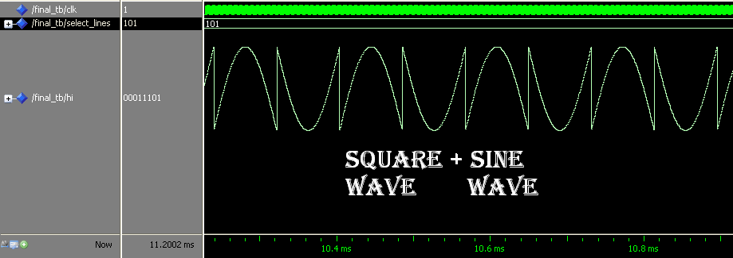
Square wave + triangular wave:
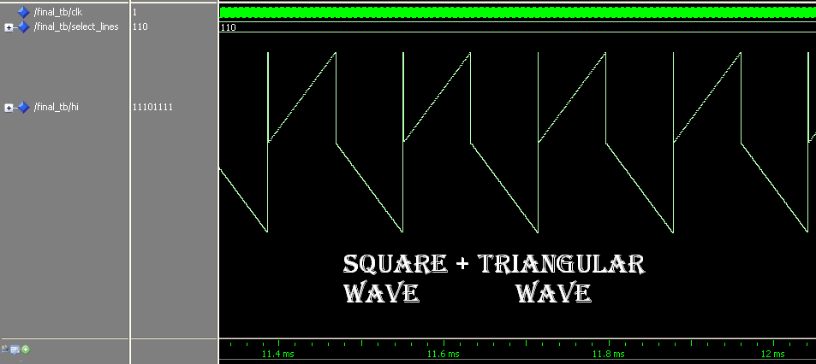
DC signal:
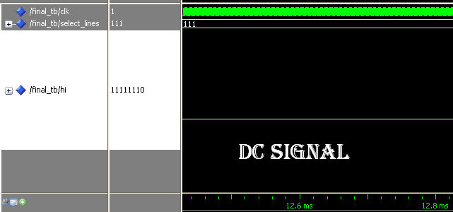

Overall output:
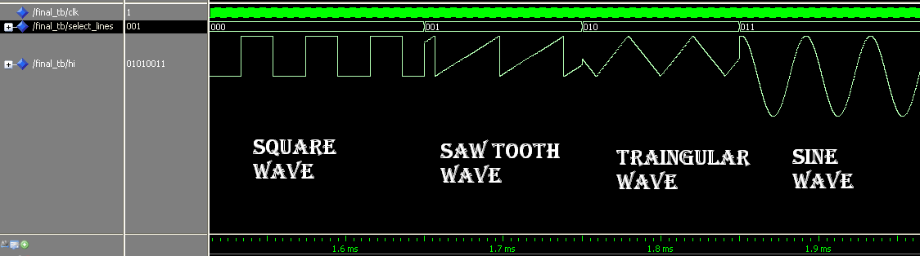
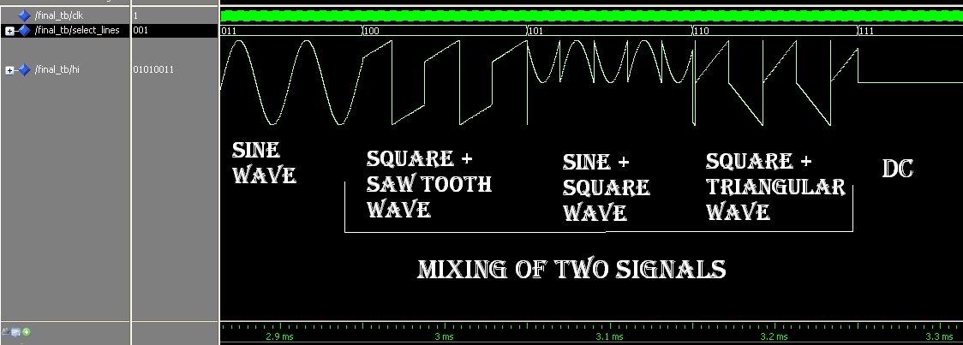

MERITS OF DDS SIGNAL GENERATOR:
1) The tuning resolution can be made arbitrarily small to satisfy almost any design specification.
2) The phase and the frequency of the waveform can be controlled in one sample period.
3) The DDS implementation is always stable, even with finite-length control words. There is no need for an automatic gain control.
4) The phase continuity is preserved whenever the frequency is changed (a valuable tool for tunable waveform generators). But in conventional signal generators, the phase of the waveform will change if the waveform is tuned or changed.
5) DDS consumes very less power compared to conventional signal generator. Because the FPGA and DAC consumes only very less power compared to analog signal components in the analog signal generator.
INFERENCES:
- We first implemented sine wave generation using Taylor series method. But this method does not give exact values of sine signal for higher phase values. This method also needed more no of multiplications. So we adopted another method called look up table method. Though it needed a little memory, it is an effective method to generate sine wave.
- Not only the standard signals such as sine wave, square wave can be generated but also any kind of periodic wave form can be achieved using DDS. Even we can create any arbitrary waveform we like.
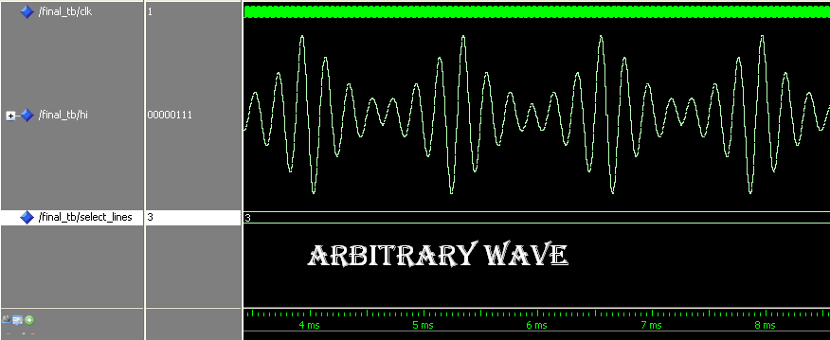
We just need to generate the waveform in the computer and feed it into FGPA lookup table values. This kind of arbitrary waveform generation is impossible in conventional function generators.
- We can implement any kind of modulation and mixing of signals using DDS signal generator. When we use a analog circuit or other components to perform modulation or mixing of two or more signals, the device noise will be added to the output waveform. But in DDS there is no chance of noise because all the modulation and mixing are done digitally and the output waveform is noise-free.
- Any kind of signal processing techniques can be implemented in FPGA. Before sending the digital values to DAC, we can perform digital signal processing which gives more flexibility and power to the FPGA based design of signal generator.
- The DAC chip should be operated at the range of MHz because the output of the FPGA is in Mega Samples per second. The advised D/A convertor chips are AD9761, AD9783, AD9780, AD5433, AD5440, ADV7122, AD768 etc.
- The amplitude of the output waveform is controlled by an amplifier which can be tuned using a potentiometer. It is very easy to implement this type of signal generator.
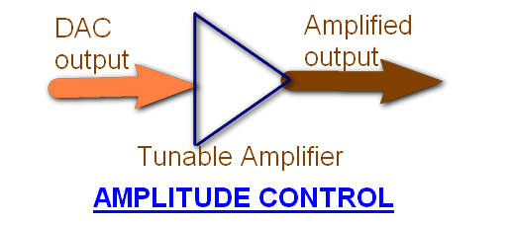
- Frequency control: the frequency of the signal can be controlled by three ways.
- By varying the clock of the FPGA externally by hardware.
- By varying the ‘n’ value the length of the waveform varies and hence the frequency of the signal changes.
- By implementing a frequency divider in the vhdl code of the FPGA. This method is very helpful if you want to decrease the frequency in large scale. In our code, we implemented this kind of approach to vary the frequency.
When we implement both methods b) and c) we can achieve any signal with any frequency. This is the major advantage of DDS FPGA signal generator.
CONCLUSION:
Thus, Direct Digital synthesis is used to generate any waveform in FPGA. DDS is a valuable technique that can be applied to generate any waveform at any frequency. When implemented using DDS along with Signal processing techniques, we can modulate, encode, encrypt, any signal digitally and generate it. Moreover, it can also be interfaced with computer, which enables the user to view or access the waveforms generated by the FPGA. This FPGA design can be implemented to ASICs and the power consumed will be reduced further. Thus DDS turns to be effective technique based on signal quality, phase noise, very low device noise, low power consumption, size, etc.
REFERENCES:
- DDS application notes #5 – www.thinkSRS.com
- DDS- A tool for periodic wave generation - Lionel Cordesses.
- Circuit Design with VHDL – Volnei A. Pedroni

